DSA0603 Data Handling and Visualization
CO2 - Assessment Test 5 (AT2) - Visualization Development Exercise
Slot B
Question 1: Chart Selection
Scenario | Best Chart | Category | Justification
1. Comparing total revenue across 6 product categories in one year. | Bar Chart | Amounts | Bar charts compare discrete amounts across categories clearly using bar length.
2. Showing how the salary distribution differs across 4 job levels. | Box Plot | Distribution | Box plots show median, spread and outliers for each group side by side.
3. Showing market share of 5 competing brands. | Pie Chart | Proportion | Pie charts show parts of a whole, suitable for a small number of shares that sum to 100%.
4. Showing the relationship between advertising spend and sales revenue. | Scatter Plot | x-y Relationship | Scatter plots reveal correlation and trend between two continuous variables.
5. Showing monthly website traffic over 3 years. | Line Chart | Temporal | Line charts show continuous change and trend of a variable over time.
6. Showing which employees report to which managers in an org. | Network / Tree Diagram | Network | Network diagrams show hierarchical reporting relationships between nodes.

Question 2: Average Score Dataset

R Code:
library(ggplot2)
library(dplyr)

score_data <- data.frame(
Subject = c("Mathematics", "Science", "English", "History", "Computer Sci"),
Average_Score = c(72, 68, 75, 64, 81)
)

score_data <- score_data %>%
mutate(Highlight = ifelse(Average_Score == max(Average_Score), "Highest", "Other"))

ggplot(score_data, aes(x = reorder(Subject, -Average_Score), y = Average_Score, fill = Highlight)) +
geom_col() +
geom_text(aes(label = Average_Score), vjust = -0.5, size = 4.2) +
scale_fill_manual(values = c("Highest" = "#DD8452", "Other" = "#4C72B0")) +
labs(title = "Average Score by Subject (Descending)", x = "Subject", y = "Average Score") +
theme_minimal(base_size = 13) +
theme(legend.position = "none")

R Chart:
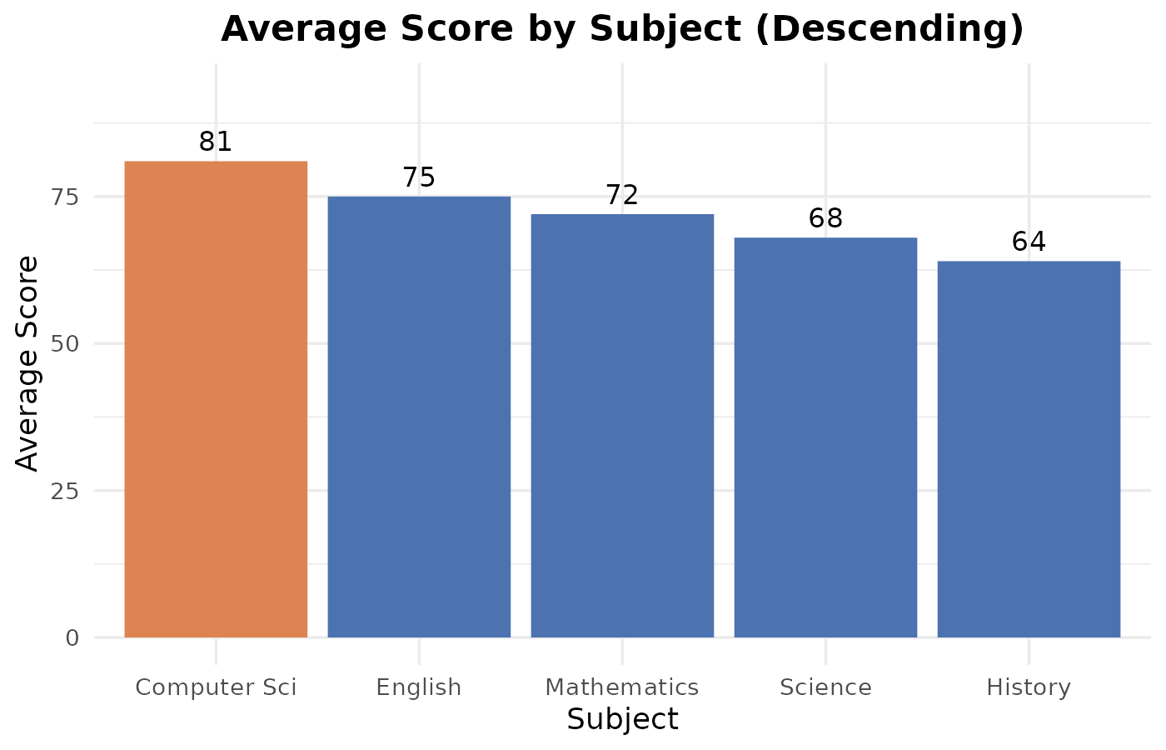
Interpretation:
Computer Science has the highest average score at 81, followed by English at 75. History has the lowest average score at 64. The scores show a moderate spread of 17 points between the highest and lowest subjects, with no extreme outliers.
Question 3: Regional Sales Dataset

R Code:
library(ggplot2)
library(dplyr)
library(tidyr)

sales_data <- data.frame(
Region = rep(c("North","South","East","West"), each = 4),
Quarter = rep(c("Q1","Q2","Q3","Q4"), times = 4),
Sales_000s = c(120,135,128,150, 95,110,105,130, 140,138,145,160, 80,85,90,100)
)

# 1. Grouped bar chart
ggplot(sales_data, aes(x = Region, y = Sales_000s, fill = Quarter)) +
geom_col(position = "dodge")

# 2. Stacked bar chart
ggplot(sales_data, aes(x = Region, y = Sales_000s, fill = Quarter)) +
geom_col(position = "stack")

# 3. Dot plot: total annual sales per region, ranked
totals <- sales_data %>% group_by(Region) %>% summarise(Total = sum(Sales_000s)) %>% arrange(Total)
ggplot(totals, aes(x = Total, y = reorder(Region, Total))) +
geom_point(size = 4, color = "#4C72B0")

# 4. Heatmap
ggplot(sales_data, aes(x = Quarter, y = Region, fill = Sales_000s)) +
geom_tile() +
scale_fill_gradient(low = "#fff5eb", high = "#d94801")

R Visualizations:
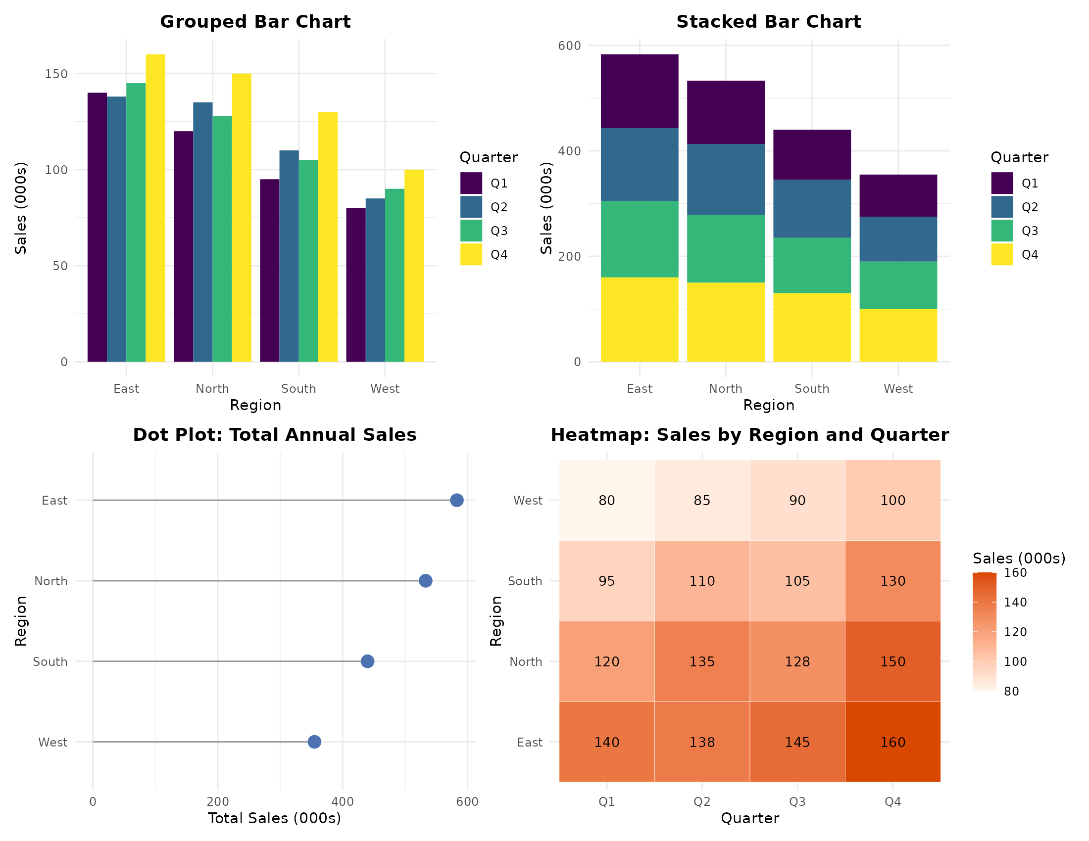
Interpretation:
East and North have the highest sales in every quarter, while West is consistently the lowest. All four regions show growth from Q1 to Q4, with East reaching the highest total of 583 thousand for the year. The heatmap confirms Q4 is the strongest quarter across all regions, and the dot plot ranks the regions clearly by total annual sales: East, North, South, West.
Question 4: Synthetic Exam Score Dataset
R Code:
library(ggplot2)
library(dplyr)
library(ggridges)

set.seed(42)
class_a <- rnorm(40, mean = 70, sd = 8)
class_b <- rnorm(40, mean = 75, sd = 5)
class_c <- rnorm(40, mean = 65, sd = 12)
class_d <- rnorm(40, mean = 80, sd = 6)

exam_data <- data.frame(
Score = c(class_a, class_b, class_c, class_d),
Class = rep(c("A","B","C","D"), each = 40)
)

# 1. Violin plot with embedded boxplot
ggplot(exam_data, aes(x = Class, y = Score, fill = Class)) +
geom_violin(trim = FALSE) +
geom_boxplot(width = 0.12, fill = "white", outlier.shape = NA)

# 2. Ridgeline plot, ordered by mean score
class_means <- exam_data %>% group_by(Class) %>% summarise(MeanScore = mean(Score)) %>% arrange(MeanScore)
exam_data$Class <- factor(exam_data$Class, levels = class_means$Class)

ggplot(exam_data, aes(x = Score, y = Class, fill = Class)) +
geom_density_ridges()

R Charts:
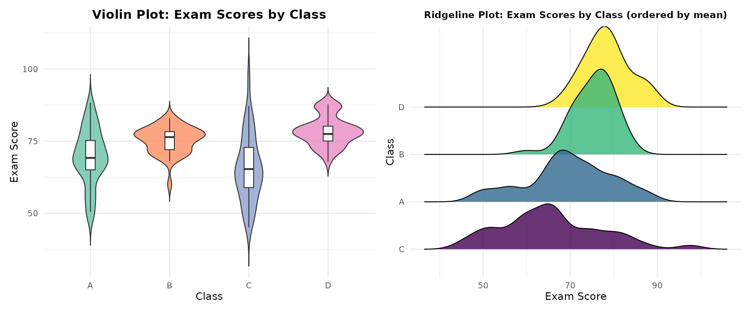
Interpretation:
Class D has the highest mean exam score and Class C has the lowest, with Class C also showing the widest spread due to its larger standard deviation. The violin plot shows Class B has the most consistent, narrow distribution. The ridgeline plot confirms the same ranking, with Class D's peak furthest right and Class C's distribution flattest and widest.
Question 5: Built-in Tips Dataset
R Code:
library(ggplot2)
library(reshape2)

data(tips)

# 1. Histogram, 30 bins
ggplot(tips, aes(x = total_bill)) +
geom_histogram(bins = 30, fill = "#4C72B0", color = "white")

# 2. Histogram + KDE
ggplot(tips, aes(x = total_bill)) +
geom_histogram(aes(y = after_stat(density)), bins = 30, fill = "#55A868", color = "white") +
geom_density(color = "black", linewidth = 1)

# 3. Grouped histogram + KDE by smoker
ggplot(tips, aes(x = total_bill, fill = smoker)) +
geom_histogram(aes(y = after_stat(density)), bins = 30, alpha = 0.5, position = "identity") +
geom_density(aes(color = smoker), linewidth = 1, fill = NA)

R Charts:
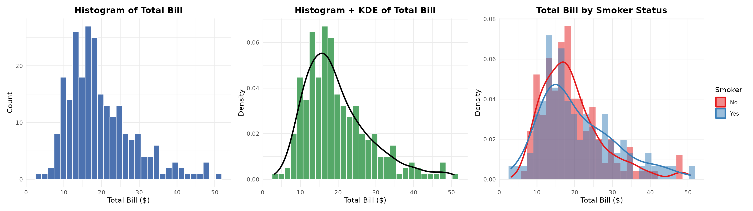
Interpretation:
The total bill distribution is right-skewed, with most bills between 10 and 20 dollars and a long tail toward higher amounts. The KDE curve confirms a single peak near 15 dollars rather than a normal distribution. Smokers and non-smokers show a similar overall shape, but non-smokers have a sharper peak at lower bill amounts while smoker bills are slightly more spread out.

